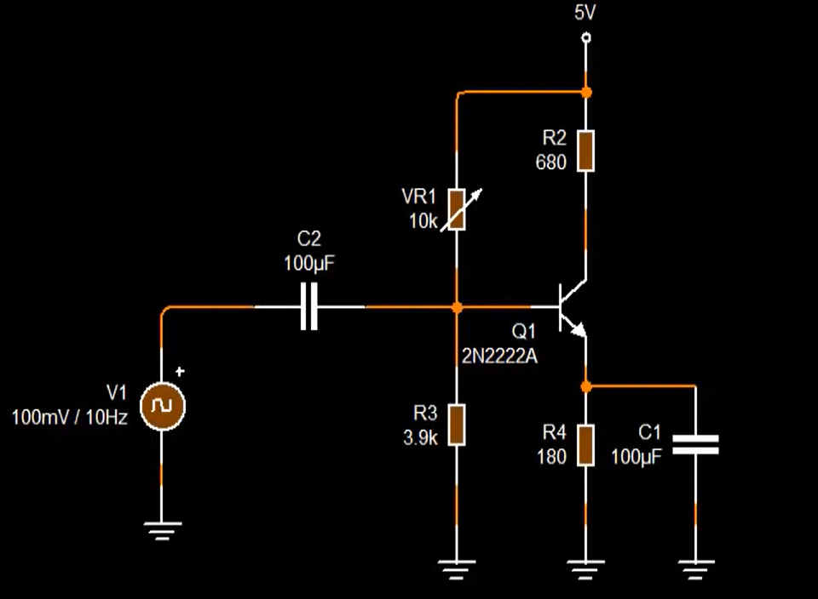

Common   
Emitter



Common   
Collector |  
Buffer |  
Voltage follower  
Used to give the same Vin but high current gain



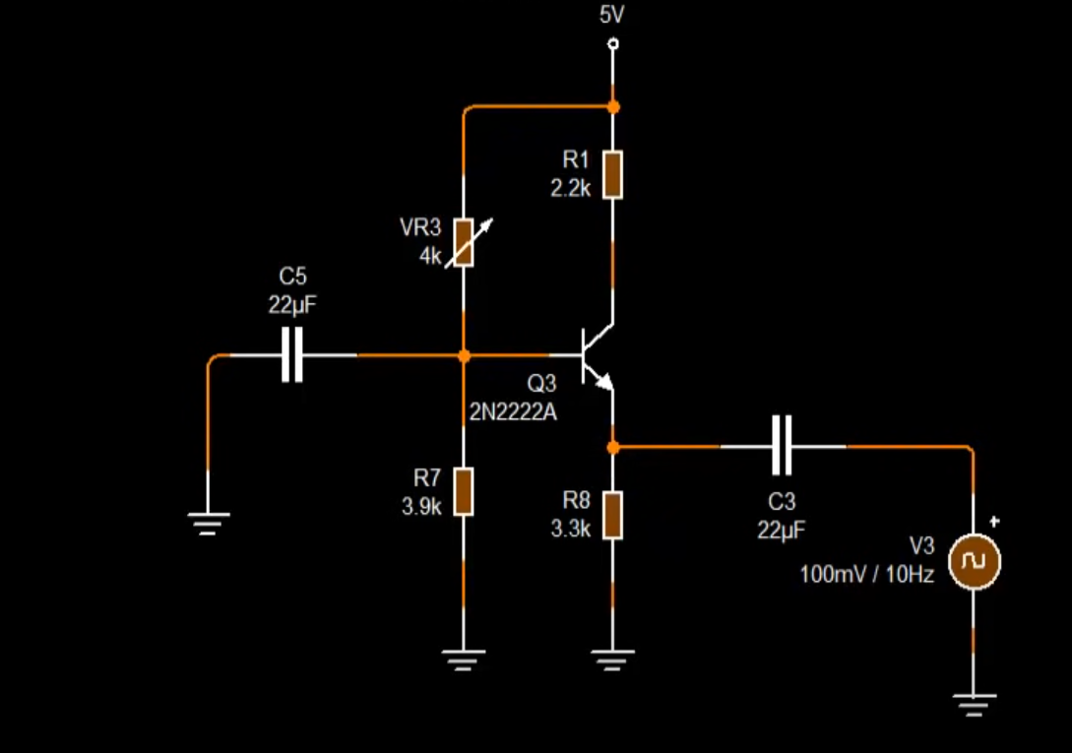

Common   
Base

Used in Communications   
Impedance matching



